SWIGGY SALES ANALYSIS 
Data Cleaning & Validation
The raw table swiggy_data contains food delivery records across states, cities, restaurants, categories, and dishes.
The first goal is to ensure data quality by performing:
Null Check
Identify missing values in:
- State
- City
- Order_Date
- Restaurant_Name
- Location
- Category
- Dish_Name
- Price_INR
- Rating
- Rating_Count

Blank/Empty String Check
Detect fields containing blank values that may cause inaccurate analysis.

Duplicate Detection
Find duplicate rows using grouping on all business-critical columns.

Duplicate Removal
Use ROW_NUMBER() to delete surplus duplicate rows while retaining one clean copy for each unique order.

Dimensional Modelling (Star Schema)
Dimensional modelling helps organize data in a way that makes analysis simple, consistent, and extremely efficient. Instead of keeping all information mixed in one large table, the Star Schema separates descriptive information into dimensions and keeps all measurable values in a central fact table. This structure reduces data duplication, improves clarity, and makes the entire dataset easier to understand. It also supports faster reporting because queries can access small, focused tables rather than scanning a single bulky dataset. Most analytics and BI tools are designed to work best with star schemas, so this approach ensures smooth dashboard creation, accurate aggregations, and reliable insights. Overall, dimensional modelling provides a clean, scalable, and performance-optimized foundation for any analytical system, regardless of the industry or data source.
To optimize analytics and reporting, build a Star Schema with the following dimension tables:
- dim_date → Year, Month, Quarter, Week
- dim_location → State, City, Location
- dim_restaurant → Restaurant_Name
- dim_category → Cuisine/Category
- dim_dish → Dish_Name
Central fact table:
- fact_swiggy_orders → Price_INR, Rating, Rating_Count, foreign keys to all dimensions
Populate each dimension with distinct data from the cleaned source and load fact table with all keys resolved.

ERD DIAGRAM: STAR SCHEMA

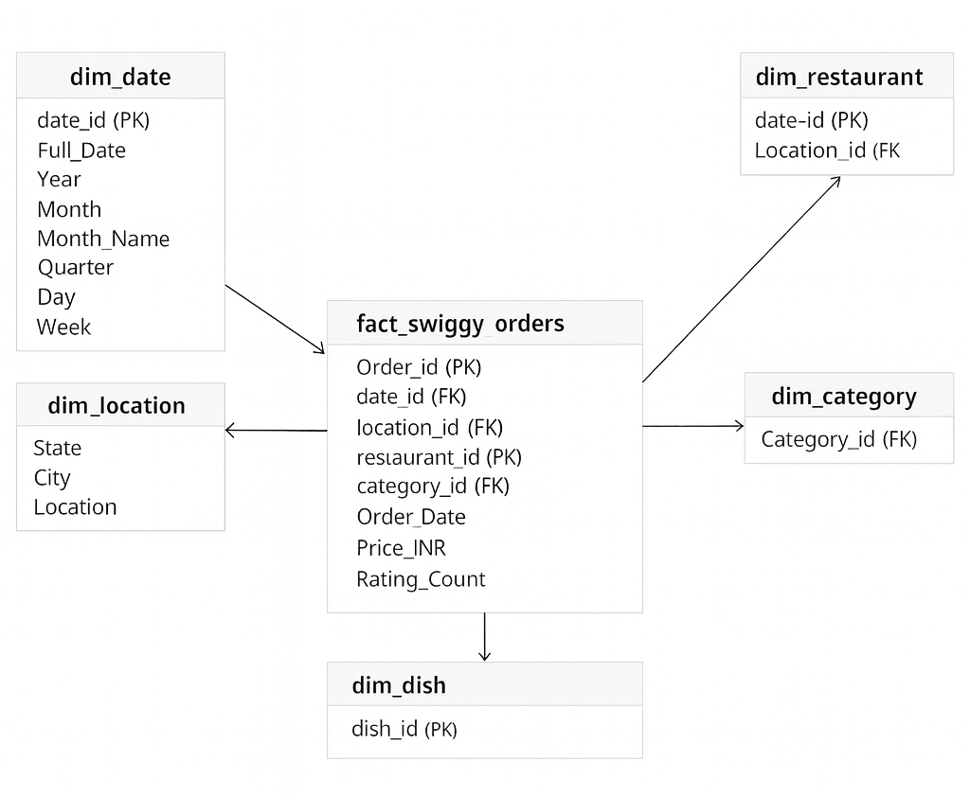

Deep-Dive Business Analysis
Date-Based Analysis
- Monthly order trends
- Quarterly order trends
- Year-wise growth
- Day-of-week patterns
Location-Based Analysis
- Top 10 cities by order volume
- Revenue contribution by states
Food Performance
- Top 10 restaurants by orders
- Top categories (Indian, Chinese, etc.)
- Most ordered dishes
- Cuisine performance → Orders + Avg Rating
Customer Spending Insights
Buckets of customer spend:
- Under 100
- 100–199
- 200–299
- 300–499
- 500+
With total order distribution across these ranges.
Ratings Analysis
Distribution of dish ratings from 1–5.
KPI’s
- Total Sales (₹) – Overall revenue generated from food orders.
- Average Rating – Customer satisfaction level across all restaurants.
- Average Order Value (₹) – Revenue per order.
- Ratings Count – Total number of customer reviews.
- Total Orders – Number of food orders received.

CHART’S
- Monthly Sales Trend – Shows how total sales fluctuate month by month.
- Daily Sales Trend – Highlights order and revenue variations across days of the week.
- Total Sales by Food Type (Veg vs Non-Veg) – Compares revenue contribution by cuisine type.
- Total Sales by State (Map Visualization) – Displays state-wise revenue distribution.
- Quarterly Performance Summary – Combines Sales, Ratings, and Orders by Quarter.
- Top 5 Cities by Sales – Identifies leading cities contributing the most revenue.
- Weekly Trend Analysis – Monitors weekly fluctuations in sales to identify consistency or peak periods.

